

CS214: Design & Analysis of Algorithms STEMP

Final Examination Semester II, 2022

F2F/Blended Mode

Duration of Exam: 3 hours + 10 minutes

Reading Time: 10 minutes

Writing Time: 3 hours

Total Marks: 40

The exam covers the following learning outcomes:
CLO – 1: Evaluate the efficiency of algorithms (32.5%)
CLO – 2: Assess the suitability of different algorithms/data structures for solving a given problem (17.5%)
CLO – 3: Solve computationally difficult real world problems using appropriate algorithmic techniques (50%)

Instructions:

1. Write your answers in the space provided in this Question Paper.
2. Answer all questions. There are 9 questions and all questions are compulsory.
3. This exam is worth 40% of your overall mark. The minimum mark to pass the final exam is 16/40.
4. The total number of pages including this cover sheet is 13.
5. This is a closed book exam. No printed materials and electronic devices are allowed.

ID:___________________________ Name:_____________________________

SeatNo: _______________________ Campus: ___________________________

This page is intentionally left blank

Page 2
ID: _______________________

Being selective when choosing data structures for your algorithm is crucial because the efficiency of operations like insertion, deletion, access, and search directly depends on the properties of the data structure. The right choice can significantly improve an algorithm’s performance, while the wrong one can lead to inefficiencies that cause bottlenecks in execution, especially for large datasets.

For example, consider searching for an element in a list. If you choose an ArrayList (with O(n) search time) instead of a HashSet (with O(1) average search time), it could slow down your algorithm drastically if the list is large. Similarly, using a LinkedList for frequent random access is inefficient because it takes O(n) time to access elements by index, whereas ArrayList offers O(1) access time.

There's no one-size-fits-all data structure. Each has its strengths and weaknesses depending on the type of operation you prioritize. For instance, ArrayList is great for random access and sequential storage, while HashMap provides fast key-value lookups, and LinkedList excels at quick insertions and deletions. Selecting the right data structure involves understanding the operations your algorithm will rely on most and optimizing for those.

a) Find the worst case time complexity [12 mins]: final int P = 100;
final int Q = 50;

for (int i = 0; i < P; i++) {
for (int j = 0; j < Math.min(i,Q); j++) { System.out.println(j);
} }

Page 3
ID: _______________________

int a = 0;
for (i = 0; i < N; i++) {
for (j = 0; j < 10; j++) { a = a + i + j;
} }

Page 4
ID: _______________________

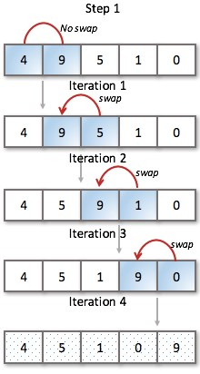
static void bubbleSortSimple (int S[]){

int n = S.length; int temp;

for (int j = 1; j < n; j++) {
for ( int i=0; i < n-1; i++ ) { if (S[i+1] < S[i]) {

temp = S[ i ];
S [ i ] = S [ i+1 ]; S [ i+1 ] = temp;
} }
}
}

…

(answer both questions 5.1 and 5.2 here)

Page 5
ID: _______________________

int bin (int n, int k){ if (k == 0 || n==k)
return 1; else
return bin(n-1, k-1) + bin(n-1, k); }




Hint: It has only every-case time complexity.

n k

n-1 k-1

+

n-1 k

... ... ... ...

bin(n, k)
/ \
bin(n-1, k-1) + bin(n-1, k)
/ \ / \
bin(n-2, k-2) + bin(n-2, k-1) bin(n-2, k-1) + bin(n-2, k)
...

Best-Case Time Complexity
In divide-and-conquer approaches like this, there isn't much distinction between best and worst-case complexity because the recursion tree has a fixed structure that does not vary with input, leading to O(2^n) in all cases (every-case time complexity).

Are You Satisfied with O(2^n) Time Complexity?
No, O(2^n) time complexity is not efficient for larger values of n. The exponential growth of recursive calls makes this approach computationally expensive as n increases, especially when calculating large binomial coefficients.

How Can It Be Improved?
This solution can be drastically improved using Dynamic Programming (DP) or Memoization to avoid redundant calculations. In the recursive approach, the same subproblems (like bin(n-1, k-1)) are solved multiple times, leading to redundant work.

While the recursive divide-and-conquer solution has an O(2^n) time complexity, using dynamic programming can reduce it to O(n × k), making the algorithm much more scalable for larger inputs. Therefore, the DP approach is highly preferable when calculating binomial coefficients efficiently.

Page 6
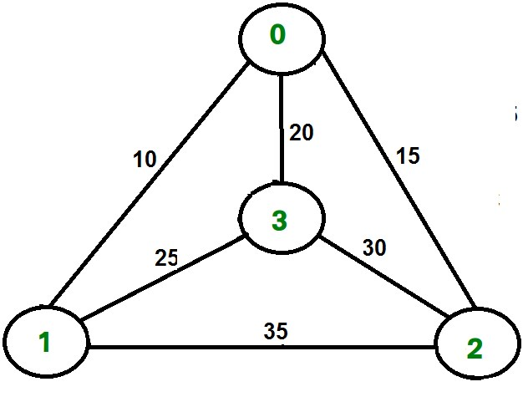
ID: _______________________

Page 7
ID: _______________________

Page 8
ID: _______________________

Character B
F H I L M
S
Frequency Code 2 01111 1 01110 3 0110 ? 00
5 010 15 10
15 11

Page 9
ID: _______________________

item 1 (2kg, $3) item 2 (1kg, $5) item 3 (3kg, $5) item 4 (8kg, $9) item 5 (2kg, $3)

The knapsack has a capacity of 8 kg.

Do the following by showing your complete working: [30 mins]

Page 10
ID: _______________________

Page 11
ID: _______________________

Page 12
ID: _______________________

Page 13

